Randy Sirota  Director of Volunteer Services  VOLUNTEER SUPPORT TRAVEL AUTHORIZATION DURING COVID-19 OUTBREAK | 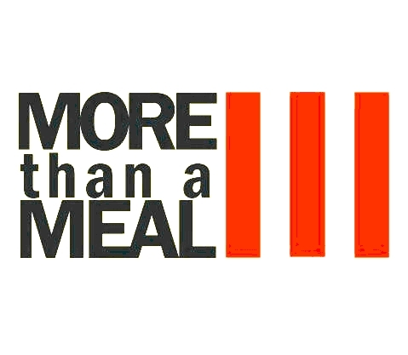

To Whom it May Concern:

More Than A Meal, Inc. is committed to a responsible approach to the COVID-19 global outbreak. Our top priority is the health and safety of our people, customers, and the public.
Our Volunteer provides essential services and or products and is operating under current public health and government orders as "Workers who support food, shelter, and social services, and other necessities of life for economically disadvantaged or otherwise needy individuals, such as those residing in shelters". More Than A Meal, Inc. is providing food, clothing, and toiletries to prevent our disadvantaged community members from having to go without these basic needs.
[NAME OF VOLUNTEER], the bearer of this letter is authorized by More Than A Meal, Inc. to travel to the Saturday morning breakfast at 502 N Walnut St. Colorado Springs CO 80905 in order to solely provide these services. We are observing added safety precautions by providing food and toiletry services outside, social distancing, and enhanced hygiene protocols in alignment with public health guidelines. Additionally, we are moving people on after providing them with supplies.
This work is necessary to provide services in line with current public health requirements. Thank you for permitting the continued efforts of More Than A Meal, Inc. to support our community’s response to the COVID-19 outbreak.

Regards,

Randy Sirota

